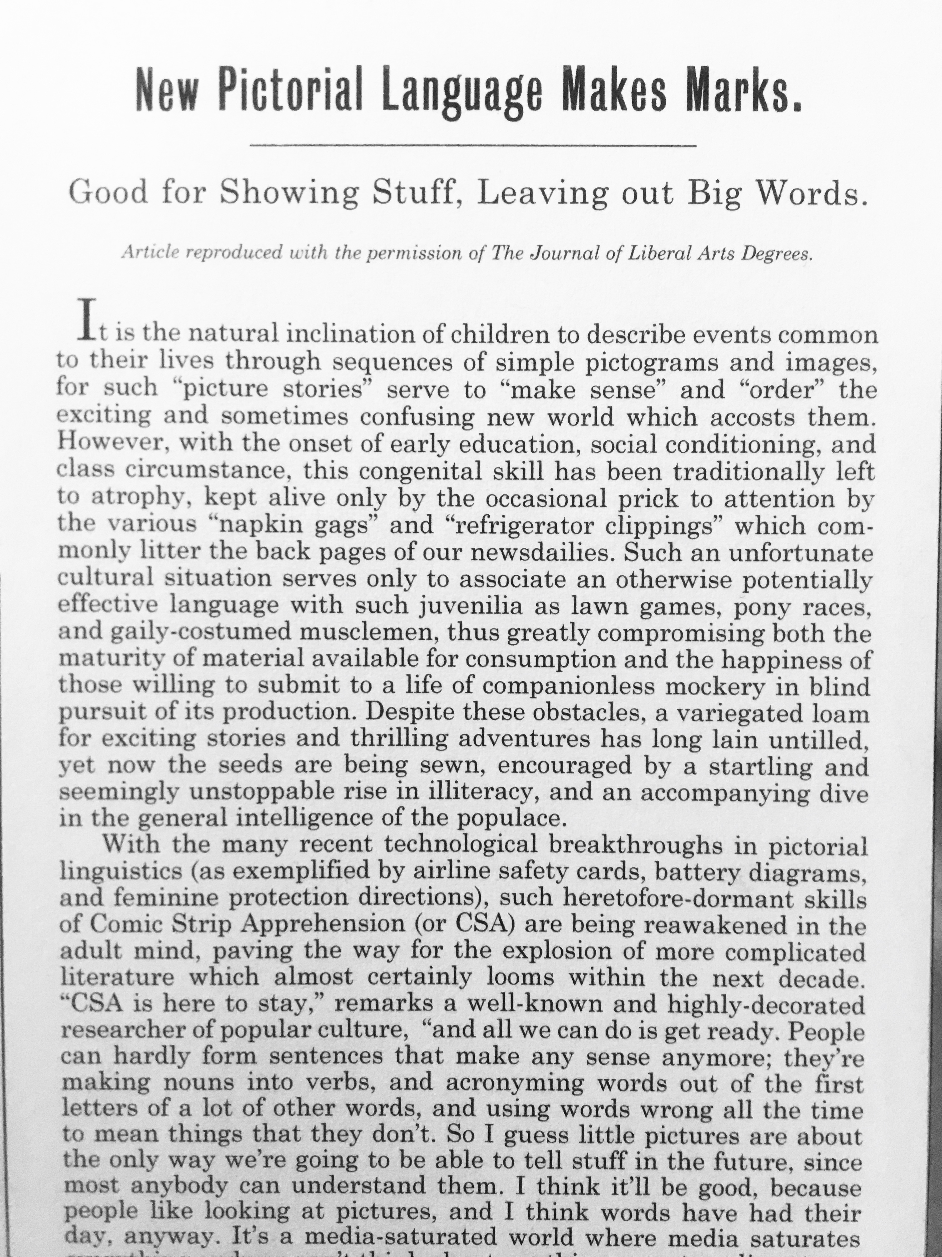

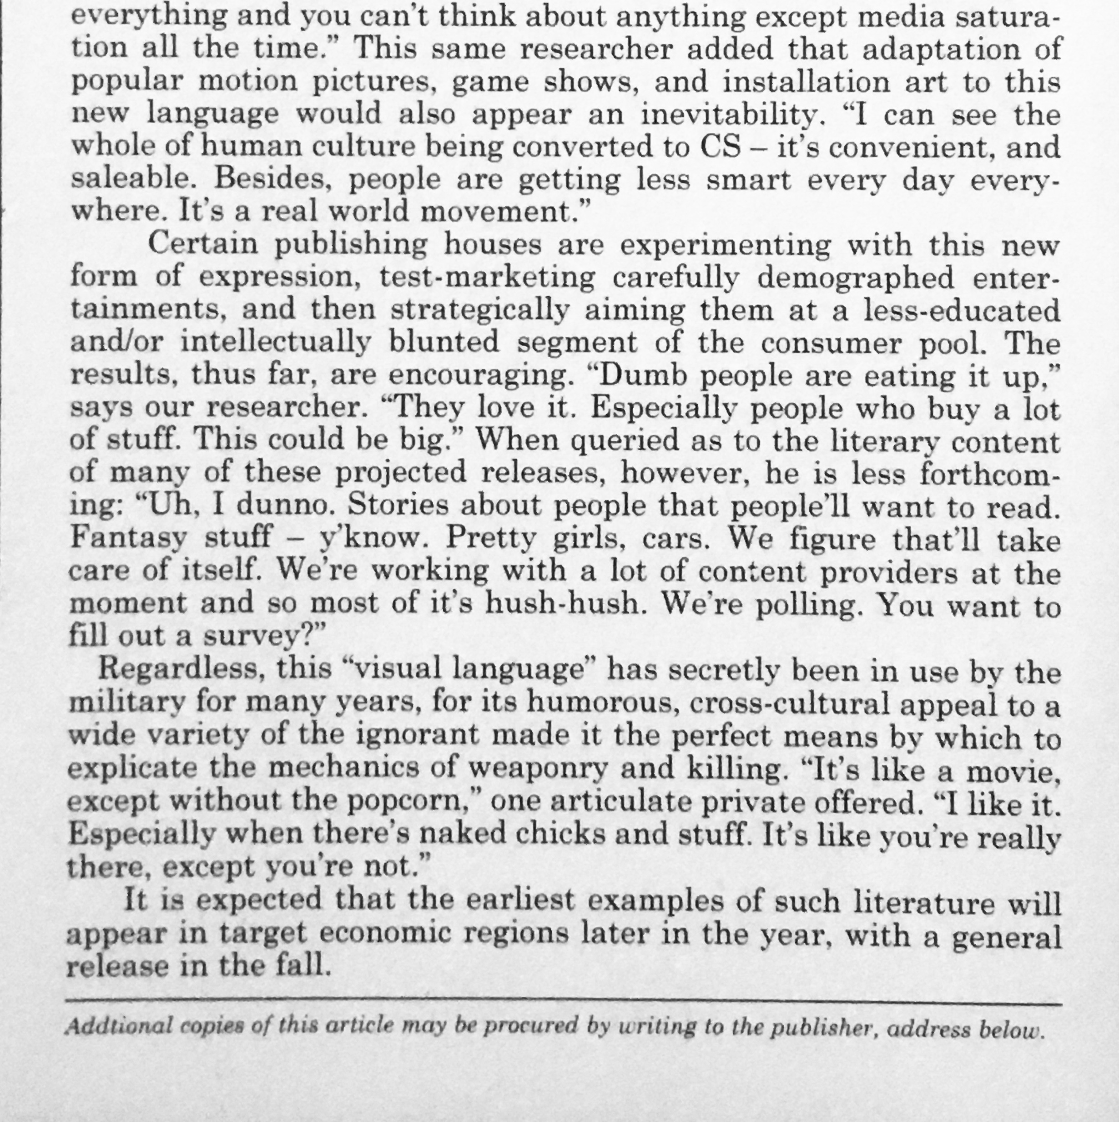
Article: Jimmy Corrigan: The Smartest Kid on Earth
(Pantheon Books released the book in 2000 following its serialization in the newspaper Newcity and Ware's Acme Novelty Library series.in 1995 -2000)
Book published: 2000
Author: Chris Ware
Main Character: Jimmy Corrigan
Publisher: Pantheon Books
